European Union Rule of Law Mission in Kosovo - www.eulex-kosovo.eu

Navigating the high seas of international agreements
By Alexandra George, EULEX Customs Spokesperson
05 January, 2010
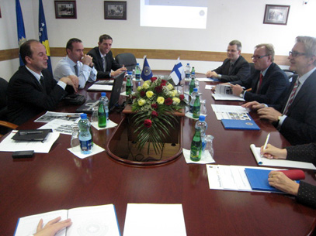
Meeting between the Director-Generals of Kosovo and Finnish Customs

A delegation of Finnish Customs headed by its Director-General, Tapani Erling, was recently in Kosovo for talks with its counterparts in Kosovo Customs. The visit, facilitated by EULEX Customs as part of their monitoring, mentoring and advisory (MMA) activities, laid the groundwork for the signing of a Finno-Kosovo agreement in April 2010 aimed at promoting integrated border management and combating organized crime, including smuggling and commercial fraud.
The visit was a continuation of bilateral meetings held last year in Helsinki, which marked the beginning of the pilot project involving transfer of skills on how to negotiate agreements, including what steps to follow.
The underlying principle behind the project is that serious cross-border crimes can only be resolved through international cooperation. Thus this initial agreement with Finland is envisaged as the first stone in the bridge of cooperation that is being built and is to involve agreements with around 19 countries. The prospects look positive since Finland, as the first negotiating country, has a wealth of experience in managing its EU external borders.
According to Paul Acda, Head, EULEX Customs: “Part of our programme activities specify that we not only mentor and advise the Kosovo Customs Legal Directorate to review all existing agreements, but also ensure that they conclude cooperation and mutual assistance agreements with as many countries as possible. The EULEX Customs Component is to participate actively in the negotiations and also encourage the Kosovo Customs Legal Directorate to take initiative on possible new agreements.”
According to Harri Saastamoinen, EULEX Customs Legal Advisor, “the pilot project’s aim is to transfer skills to KC officers how to negotiate and conclude international agreements in the area of Customs. Trade is the key issue here: the challenge of modern customs is the dramatic increase in trade which requires a balance between customs controls and ensuring smooth foreign trade.”
Institution-building is an important part of nation-building. Thus when Kosovo declared its independence, Kosovo Customs became responsible for negotiating its own international agreements, for example on crime prevention and data sharing. Prior to that, UNMIK had negotiated customs agreements on its behalf, for example with FYROM and Albania. Currently, apart from Finland, Kosovo plans to sign a similar agreement with Turkey in January 2010.
“This project is important because integrated border management is one of the EU’s conditions for liberalization of visas and, looking down the path, for EU integration. Furthermore, joint cooperation with Finland in combating organized crime is of mutual interest,” said Naim Huruglica, Director-General, KC.

Home | Press Releases | Videos | Photo Gallery | Contacts

